## Implementation Approach

### Our Approach

KPMG Powered Enterprise is KPMG's approach and methodology to functional transformation. That is business-led and user experience, orientated designed to:

* Engage business users early and throughout the project.
* Start with the model answer to allow the project to focus on those truly unique requirements to CFTRF.
* Drive a business outcome that realises benefits.
* Avoid recreation of any exiting disparate or cumbersome processes from legacy applications.

Cloud SaaS solutions offer limited to no ability to customise the product. Where there are unique requirements that cannot be fulfilled through the product's configuration, clients must adapt their operating model (processes, policies, roles) to meet the needs. In response to this, KPMG's approach to a Workday HCM implementation is not just focused on the technology. To achieve user adoption and reap the benefits of Workday, KPMG takes a holistic view of both the technology, the operating model, and workforce management practices.

KPMG leads every Workday implementation using KPMG Powered Enterprise enabled by Workday. Our innovative and proven approach to transformation combines deep Workday HCM functional knowledge, leading HR practices, Change Management enablers and pre-configured Workday HCM business processes coupled with process automation to drive a greater certainty of outcome and sustainable development change.

Fundamental to our approach is the use of KPMG Powered Enterprise for Workday HCM, and we believe that the most significant benefit to CFTRF is access to the pre-configured solution, out-of-the-box business processes, and delivery tools, meaning:

* CFTRF can adopt 80% of the future state business processes and Workday HCM from the start of the project, which would enable the SMEs and stakeholders to make informed design decisions and achieve greater standardisation.
* KPMG’s implementations focus with CFTRF would be more about the user uplift and adoption, refinements to the new operating model and less about the Workday technology itself.
* CFTRF will have access to KPMG materials, which have been designed through extensive global research and hands-on experience.
* CFTRF can leverage the relevant industry KPMG Powered Enterprise Workday assets developed specifically for Healthcare.

Our implementation framework and validation-based approach through KPMG Powered Enterprise enables CFTRF to achieve greater certainty of the outcome on your Return on Investment (ROI).

We’ve made cloud transformation – the new way to create business value that lasts – more straightforward, faster, and more predictable.

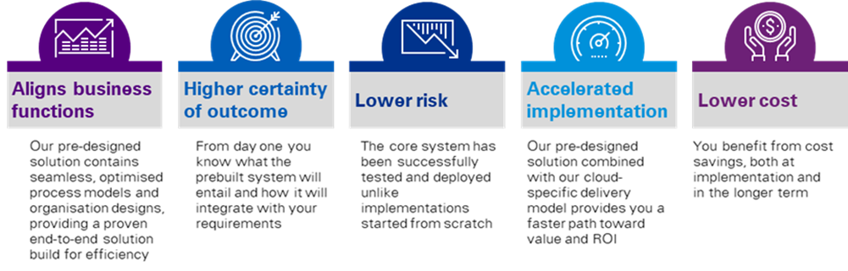

Figure 6: KPMG Powered Enterprise Benefits to CFTRF.

How Do We Achieve the Best Outcome? We Start With the “Model” Answer.

KPMG’s Powered HR contains our leading practices and Workday across a six-layer operating model, as described in below. We have codified our experience over decades of HR transformation and Workday programs into the assets, toolsets, and methods to deliver lasting organisational transformation anchored around the Employee Experience.

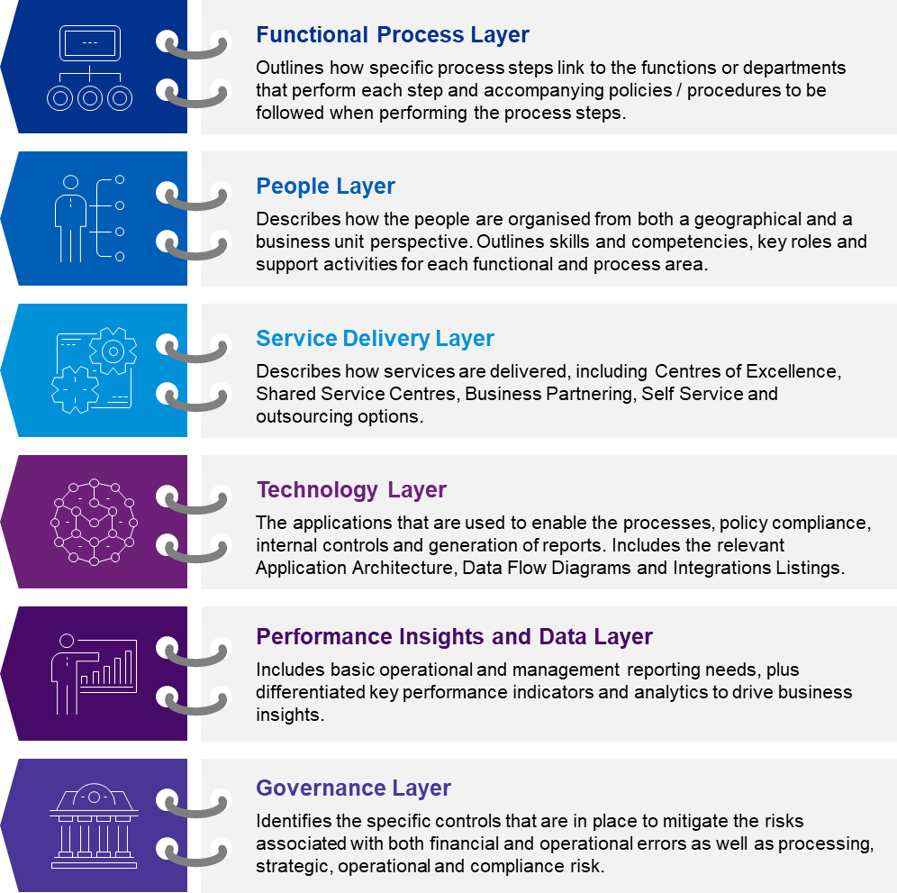

Figure 7: KPMG Powered Enterprise Six-Layer TOM Framework.

While we start with the model answer, we recognise the complexities across Workforce services, Solution Design, and stakeholder groups in CFTRF, as such we have allowed for sufficient time between the Plan and Architect stages for business SMEs and stakeholders to align on the future state of the Solution Design, while still benefiting from the KPMG Powered Enterprise assets and methodology of engaging users in the future state processes and technology as early as possible.

Core to the KPMG Powered Enterprise approach is focusing on "validating" business processes with business stakeholders to identify why the process will not work. This is with the objective of focusing on what is unique to CFTRF and follows a similar process as to that which was conducted as part of the Corporate Systems Evaluation Project early in 2021.

Note: We have proposed up-front TOM Alignment workshops during a four-week kick start period in order to understand CFTRF's new Operating Model in detail to note any alignment required to our Process, People, and Service Delivery layers of the KPMG Powered Enterprise TOM.

This is detailed further below in Section 2.5 Implementation Deliverables.

Implementation Timeline and System Implementation Approach.

We have fused leading HR practices and future HR trends to develop pre-configured deliverables, within each layer, most notably the roles, leading practice business processes with embedded controls, test scripts, scenarios, and the Workday Job Catalogue. A summary of assets within each layer is further outline in Figure 8 and Figure 9 below.

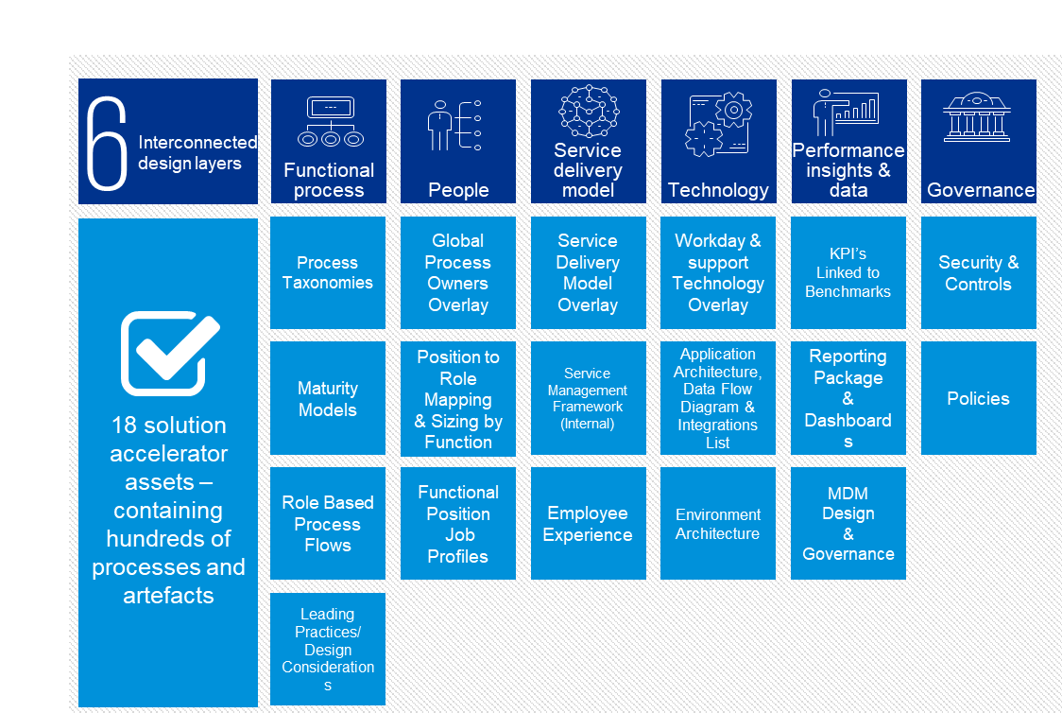

Figure 8: KPMG Powered HR TOM Assets.

As these are already aligned with Workday, there is no need to start from scratch. We provide you with 80% of the model answer, focusing on the remaining 20% unique to your business and what will make you competitive in the market.



Figure 9: KPMG Powered HR for Workday Assets.

Powered Enterprise provides the intellectual property and thought leadership required to design optimal processes alongside the Workday Platform. The result is refining the operating model to support CFTRF in enhancing the efficiency and effectiveness of operations.

Experience Led Approach

KPMG understands the design of the Workday Platform is crucial to support the Workforce team, caregivers, and line managers. Therefore, with CFTRF we would like to allocate six weeks upfront during the plan stage to address the following:

* Kick Start: We’ll workshop and agree design principles that will form the basis for the Workday design, align the deployment with the operating model, prepare the basis for Job Architecture design and engage the leadership teams
* Discovery: We'll workshop process harmonisation and identify any unique requirements which can be built into the first Foundation to support decision making during the architect phase.

CFTRF will have the opportunity to complete transactions in Workday to provide feedback on processes and streamline design decisions which increases platform awareness and saves costs on changes down the track. As part of the Architect phase, we will have localisation workshops at the start of each new wave to drive customisation and align to be fit-for-purpose.

KPMG Powered Enterprise Enabled by Workday for Healthcare

KPMG have developed industry assets specific to Healthcare on the Workday Platform – "Powered Healthcare for Workday". While the assets are across HCM, Finance, and Supply Chain Management, the HCM assets would be leveraged for CFTRF's HRIS Implementation on Workday.

Powered Healthcare for Workday was launched globally in October 2021 and would be available for CFTRF based on KPMG's unique depth of experience globally and locally in the Healthcare sector.

The six-layer KPMG Powered Enterprise TOM assets are updated across a few layers with a unique Healthcare lens:

* Functional Process: Process Taxonomy and Role Based Process Flows.
* Technology: Supporting Technology Overlay and Application Architecture.
* Performance Insights and Data: Diversity and HR Healthcare specific dashboards.

An overview of Powered Healthcare for Workday assets launched is detailed below

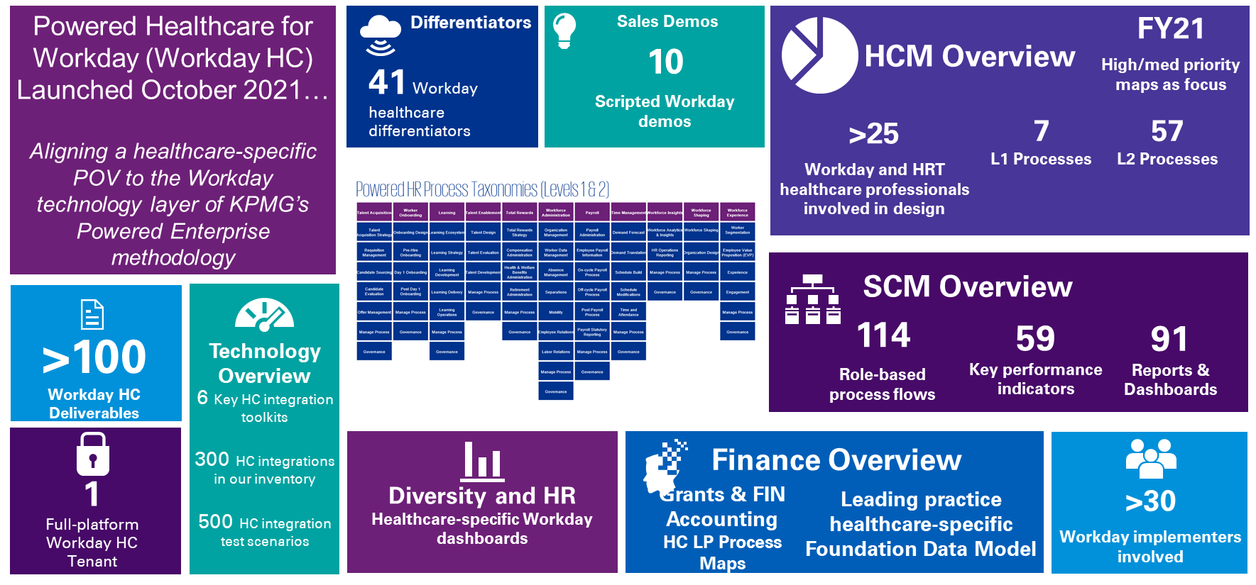

Figure 10: Powered Healthcare for Workday

### Implementation Timeline

We propose that Workday HCM be implemented to support the centralised HR functions across CFTRF, with Kronos remaining as the critical workforce management tool for time and attendance integrated with Ascender Pay. Further details on the integration solution between Workday and the other solutions that sit within your broader application landscape is detailed in this document.

We are confident that our proposed timeline strikes the right balance between the velocity needed to carefully design and deploy the Workday solution and CFTRF's decision making timelines and resource capacity to adopt the Workday solution. We believe that our approach will help CFTRF balance the right amount of internal resource involvement to drive change and increased adoption, leading to a successful transformation.

This implementation will deploy Workday functionality across the business in a single go-live requiring a robust change and communications project. Our timeline is per the following scope:

* Establishing the critical foundations. The functional scope of this phase includes the implementation of Workday‘s Core HCM, Core Compensation, Onboarding, Talent & Performance, Recruiting, Benefits, Absence Management and Cloud Connect Third-Party (Payroll Integration with Ascender Pay). This will be implemented over 15 months with additional interactive workshops in the plan stage and excluding post-go-live support (hypercare) as defined in the figure below.
* Continuous evolution. During our hypercare/post go-live stage we ensure your business is working effectively on the ground with the full capability of Workday and integrated systems. To ensure this all runs smoothly, we support with up to 3-month hypercare.

In addition, there is option to explore a phased go-live with HCM and Talent Management however, we would welcome the opportunity to conduct a joint deployment planning session with CFTRF to align the assumptions, start dates, and proposed approach.

Our top five fundamental design principles underpinning this approach to deliver the Business Case benefits are as follows:

* Out-of-the-box, Workday solution will be adopted – there is zero product customisation.
* 80% of KPMG's Powered HCM solution will be adopted – there are minimal business process and role variations.
* A unified business Go-Live – reducing the effort required to support the interim states.
* Clear project sponsorship and decision making driving the Solution Design and management of change.
* CFTRF caregivers (super users and SME's) actively engaged from the project outset to champion user adoption.

Project Kick start and Process Harmonisation

Based on CFTRF outlining not being ready to go straight into the technical implementation and the preparation projects you have proposed, such as data cleansing, job architecture etc. We have taken this into consideration combined with the KPMG Powered Enterprise approach and Workday's proven implementation methodology, to architect the proposed process harmonisation activities.

KPMG acknowledges process harmonisation is fundamental to CFTRF's objective for caregivers to have consistent processes across the employee life cycle. We have considered the objectives and requirements of the process harmonisation phase of work, including detailed process design, conducting fit / gap analysis, process documentation, and application of industry best practices.

In our experience implementing Workday, there is a unique opportunity for the business stakeholders to have early visibility into how the solution will work for them – in contrast to theoretical paper-based process map documentation. Leveraging this cloud technology and KPMG Powered HR enabled by Workday for Healthcare, we have carefully considered an approach that will meet CFTRF's process harmonisation objectives and allow sufficient time to align leadership and stakeholders efficiently and effectively to the required unified future state processes. This includes the following key activities across the Plan and Architect Stages of the proposed implementation timeline:

* Leadership alignment workshops during Plan.
* Operating model alignment workshops during Plan.
* Kick starts any preparation activities in advance of the Foundation Tenant Build, including data initialisation, job architecture etc.
* Leveraging KPMG Powered Enterprise and Powered Healthcare for Workday assets, identify key Level 2 processes with unique requirements for CFTRF.
* Conduct Architect Workshops with the objective of validating whether our leading practice processes will work for CFTRF or not. If not, this is captured as process deviations (like a fit / gap analysis).
* Once process deviations are captured, we will conduct playback sessions with the relevant stakeholders on how these deviations for CFTRF's unique requirements will be addressed and incorporated into the detailed process design workbooks. Business Process Design Workbooks include the process documentation to Level 4/5.
* These targeted activities will allow caregivers to visualise their future state solution early and leverage the KPMG Powered Enterprise approach for the right business outcome.

These activities will be spread across four months to allow for sufficient stakeholder input, review, and alignment to achieve the best outcome for unified processes for CFTRF.

Proposed Plan on a Page

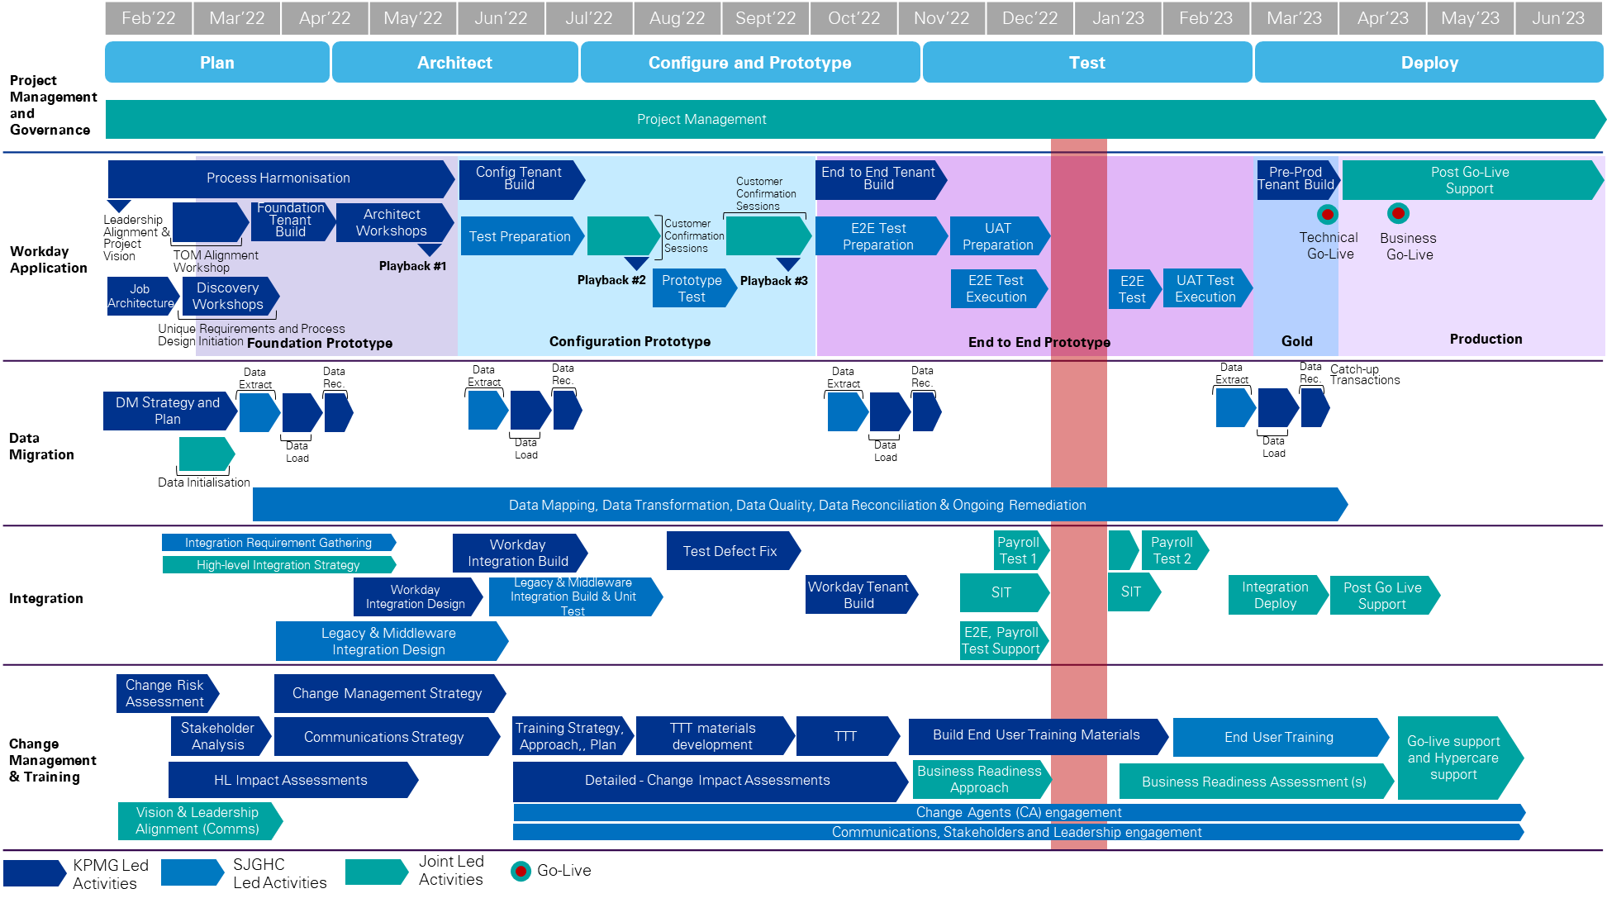

Figure 11: KPMG Proposed Timeline.

Guided by our tried and tested Powered methodology, we have a clear list of deliverables based on project milestones. Along with the key dependencies for each, these are described in detail below.

Proposed High-Level Schedule

The proposed schedule including key milestones in line with our proposed Project timeline for CFTRF is as set out in Table 8 below. Note: the key milestone dates are indicative and are subject to change based on project start dates and joint planning with SJCHC.

Functional Scope: Workday Core HCM, Core Compensation, Onboarding, Recruiting, Absence Management Talent & Performance, Benefits and Cloud Connect Third-Party (Payroll Integration).

Table 8: KPMG Proposed Schedule.

|  |  |  |  |  |
| --- | --- | --- | --- | --- |
| No. | Milestones | Description | Estimated Due Date | High-Level Dependencies/Approval Requirements |
| 1 | Project Governance Established | Governance is planned and established for project delivery. | [CURR_DATE] | Project governance, including reporting, has been endorsed. |
| 2 | Vision and Leadership Alignment Endorsed | CFTRF Leaders are aligned and engaged with the scope and governance of the transformation. | m  [CURR_DATE] | Change Risk Assessment is complete and Operating Model Alignment workshop is complete. |
| 3 | Foundation Tenant Complete | The first Workday Prototype build is complete incorporating sample data from CFTRF, and KPMG Powered Healthcare enabled by Workday HCM business processes. | [CURR_DATE] | Sample organisation data is provided by CFTRF. |
| 4 | Architect Workshops Complete | Architect workshops completed to review the Foundation prototype and discuss the future state business process design. | [CURR_DATE] | Availability of CFTRF SMEs and caregivers as per the planned sessions. |
| 5 | Configuration Tenant Complete | The second Workday Prototype build is complete incorporating agreed future state business processes in the Architect Workshops and agreed deviations from KPMG Powered Enterprise leading practice processes and configuration unique to CFTRF. | [CURR_DATE] | Future state business processes and solution designs completed and approved by CFTRF. The Master Test Plan is complete and approved by CFTRF. |
| 6 | Customer Confirmation Sessions Complete | KPMG and CFTRF co-lead the playback of the Configuration Prototype Tenant with key CFTRF business stakeholders. | [CURR_DATE] | Configuration Tenant Complete. Configuration Tenant Data Extract provided by CFTRF in the required format. |
| 7 | Prototype Test Complete | CFTRF have conducted and completed testing of the Configuration Prototype Tenant. | [CURR_DATE] | Prototype Test Scenarios are defined.  Test Closure Memo Approved. |
| 8 | End-to-End Tenant Build Complete | The third Workday Prototype build is complete incorporating agreed future state business processes, final configuration unique to CFTRF and final CFTRF security. | [CURR_DATE] | Final solution designs completed and approved by CFTRF. End-to-End Tenant Data Extract Complete and provided by CFTRF in the required format. |
| 9 | End-to-End Test Complete | CFTRF have conducted and completed testing of the End-to-End Prototype Tenant. | [CURR_DATE] | End-to-End Test Scenarios are defined.  End-to-End Test achieved the Acceptance Criteria and is Accepted.  Test Closure Memo Approved. |
| 10 | SIT is Complete and Accepted | SIT of the Solution has been executed successfully. | [CURR_DATE] | The SIT Test Plan, Test Specifications, and Test Materials are Approved.  The SIT has achieved the Acceptance Criteria and is Accepted.  Test Closure Memo Approved. |
| 11 | Exit of User Acceptance Test (UAT) | All Deliverables and Services associated with UAT are complete. | [CURR_DATE] | UAT has achieved the Acceptance Criteria and is Accepted. |
| 12 | Data Migration is Complete | All Data Migration Services have been provided, and the Data Migration Plan has been executed successfully. | [CURR_DATE] | The Approved Data Migration Plan has been successfully executed.  Relevant Acceptance Criteria is achieved and Accepted. |
| 13 | Production Deployment is Complete | The solution is deployed into production in accordance with the approved cutover plan. | [CURR_DATE] | Test Categories that occur prior to Technical Go-Live are complete and Accepted.  The solution has been deployed into production per the Go-Live Checklist. |
| 14 | Business Go-Live is complete | The solution is deployed to the business in accordance with the approved business readiness plan. | [CURR_DATE] | The solution has been deployed to the business per the Go-Live and Business Readiness Checklist. |
| 15 | Handover to Ongoing Support is Complete | Support for the Solution has been transitioned to the operational support team. | [CURR_DATE] | Handover Documentation (Solution Design documentation) is complete, approved CFTRF, and stored in CFTRF identified repository. |

### Resource Effort

Please refer below to for KPMG's resource loading, including total number of days per stream by project stage[1].

Table 9: KPMG Resource Pattern by Project Stage.

| Stream | Plan | Architect | Configure and Prototype | Test | Deploy[2] |
| --- | --- | --- | --- | --- | --- |
| Project Management | 55.00 | 53.50 | 66.00 | 39.00 | 37.50 |
| Functional and Solution Stream | 96.00 | 326.00 | 305.00 | 114.00 | 146.00 |
| Change Management and Training | 24.00 | 111.00 | 159.50 | 61.50 | 13.50 |
| Integration | 19.50 | 39.50 | 89.00 | 48.00 | 59.00 |
| Data Migration | 60.00 | 34.00 | 43.00 | 21.00 | 32.00 |
| Total | 254.50 | 564.00 | 662.50 | 283.50 | 288.00 |

1. Excluding Additional Offerings outlined in our Fees Section.
2. Including Post Go-live Support.